# social capital index over the years

Global indexes like the Social Capital Index (SCI) give a base for comparison between countries over the years. Figure 1 below shows the SCI index captured by Solability (2024) for 180 countries in 2019 and 2023. This index measures health, security, freedom, equality, and life satisfaction within a country, and was captured based on 190 quantitative indicators derived from international organizations like the World Bank, IMF, and UN (Solability, 2024). Comparison of other indexes like Natural Capital, Resource Efficiency & Intensity, Social Cohesion, Economic Sustainability, and Governance Efficiency among countries also hold the potential to numerically establish that a shock affects countries differently depending on its characteristics. For example, a flood might not have the same impact in a Scandinavian country (highest SCIs in the rank) as a country in East Africa (SCIs below average), and that difference can be indirectly assessed with these and other indexes.

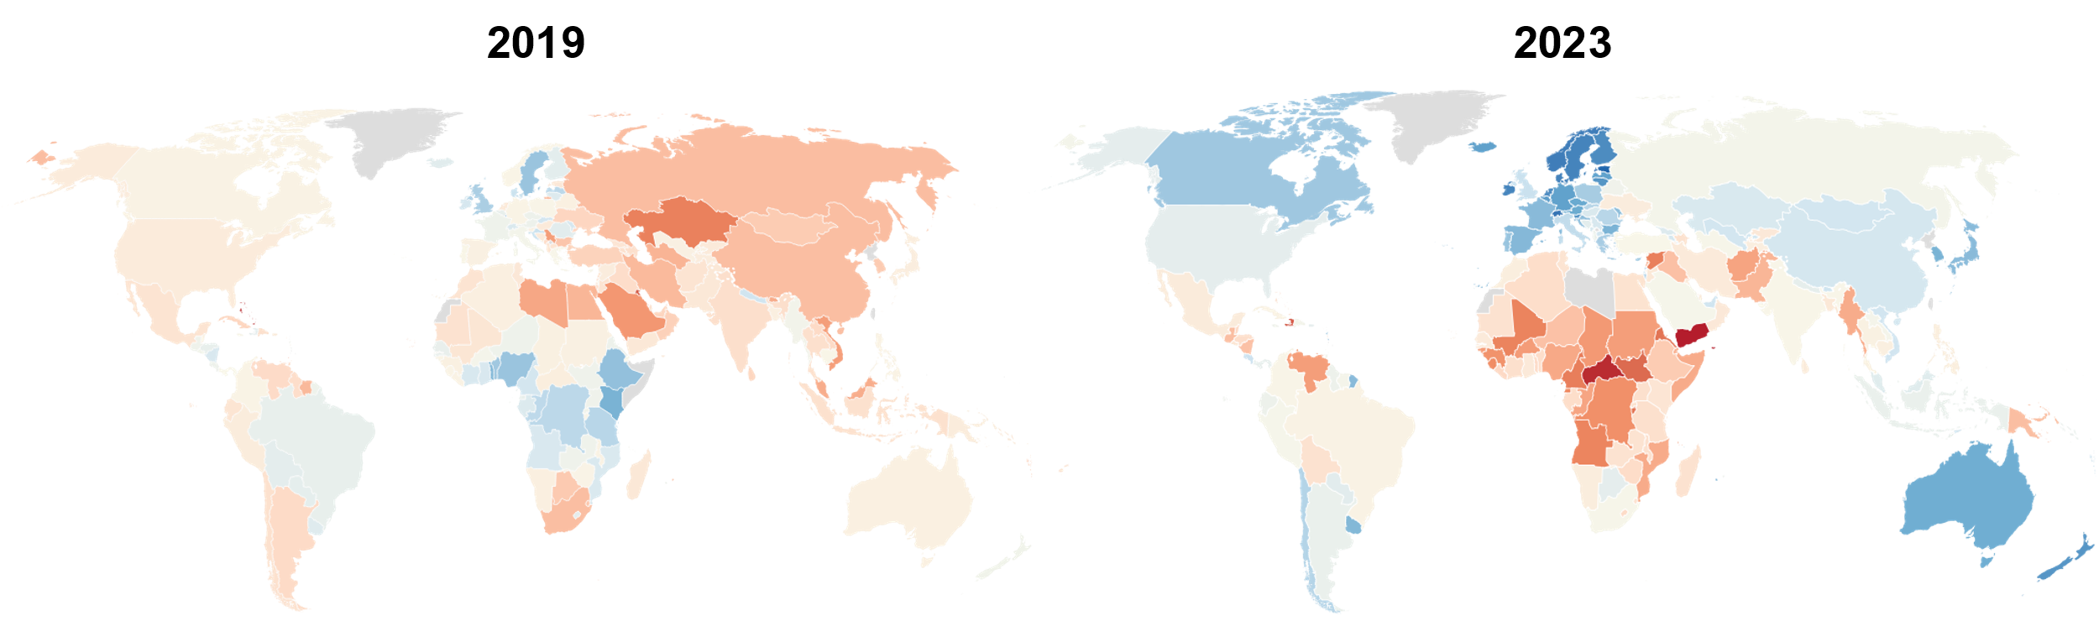

Figure 1. Social Capital Index per year.

REFERENCES

Solability. (2024). *The Global Sustainable Competitiveness Index*. <https://solability.com/the-global-sustainable-competitiveness-index/the-index>.